**DAY 4 SQL ASSIGNMENT [JOINS]**

**Greeshma Ravula DA 164**

**QUESTION 1)**

**List all customers and the products they ordered with the order date. (Inner join)**

**QUERY DETAILS**

SELECT

c.company_name AS customers,

o.order_id,

p.product_name,

od.quantity,

o.order_date

FROM

customers c

INNER JOIN orders o ON c.customer_id = o.customer_id

INNER JOIN order_details od ON o.order_id = od.order_id

INNER JOIN products p ON od.product_id = p.product_id;

**SCREENSHOTS**

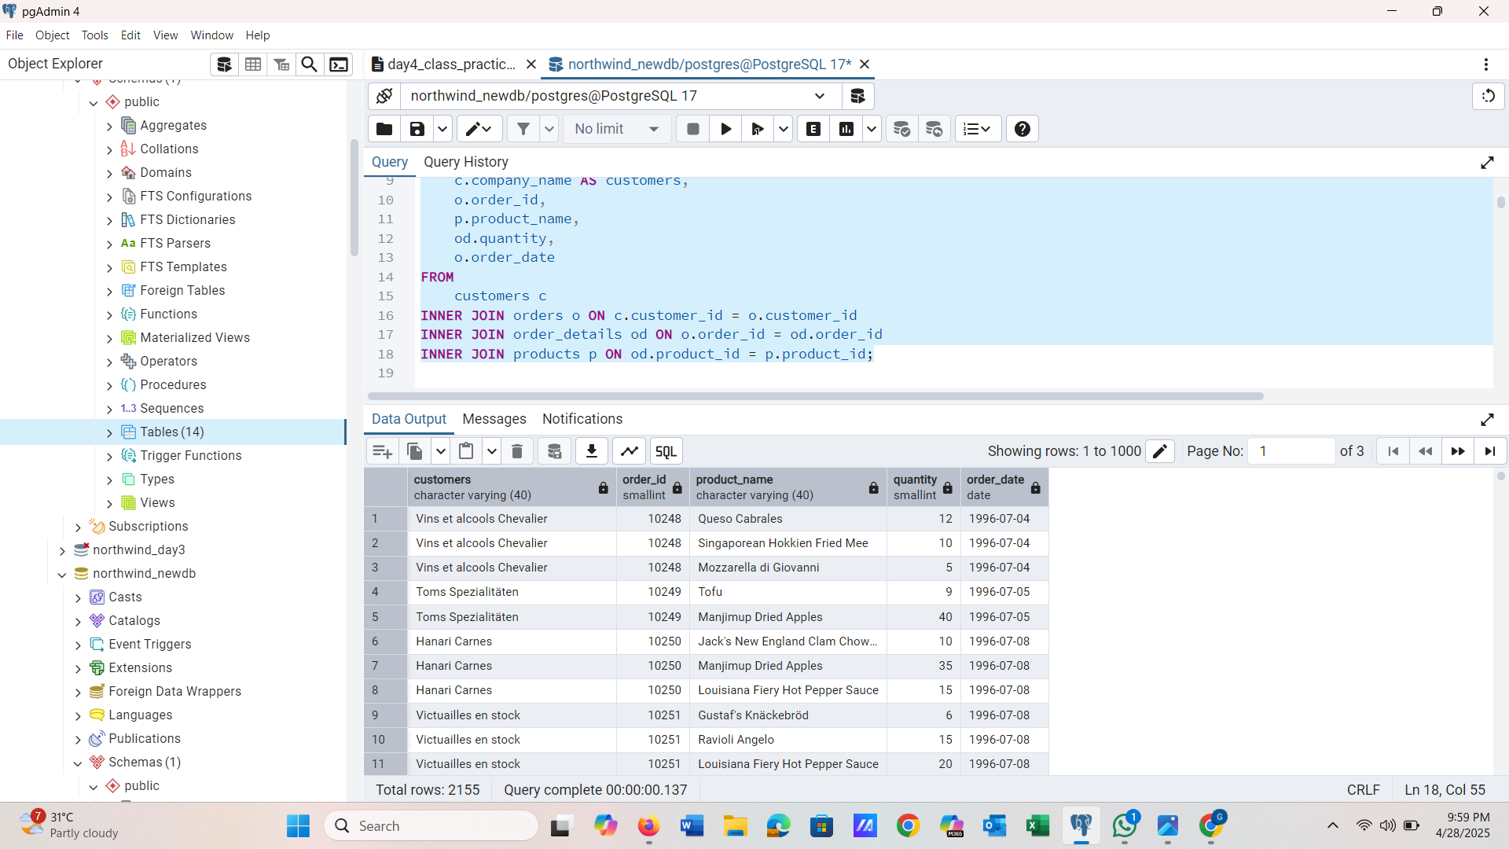

**QUESTION 2)**

**Show each order with customer, employee, shipper, and product info — even if some parts are missing. (Left Join)**

**QUERY DETAILS**

SELECT

o.order_id,

c.company_name AS customer,

e.first_name || ' ' || e.last_name AS employee,

s.company_name AS shipper,

p.product_name,

od.quantity

FROM orders o

LEFT JOIN customers c ON o.customer_id = c.customer_id

LEFT JOIN employees e ON o.employee_id = e.employee_id

LEFT JOIN shippers s ON o.ship_via = s.shipper_id

LEFT JOIN order_details od ON o.order_id = od.order_id

LEFT JOIN products p ON od.product_id = p.product_id;

**SCREENSHOTS**

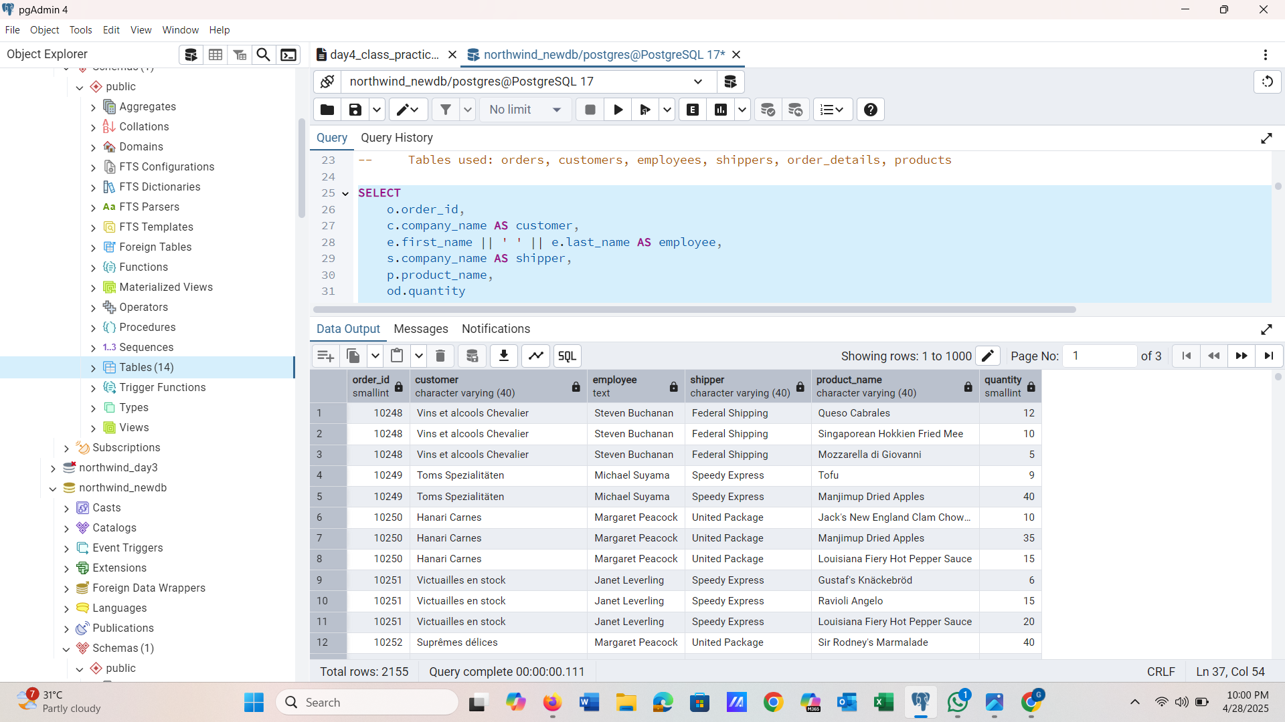

**QUESTION 3)**

**Show all order details and products (include all products even if they were never ordered). (Right Join)**

**QUERY DETAILS**

SELECT

od.order_id,

p.product_id,

od.quantity,

p.product_name

FROM order_details od

RIGHT JOIN products p ON od.product_id = p.product_id;

**SCREENSHOTS**

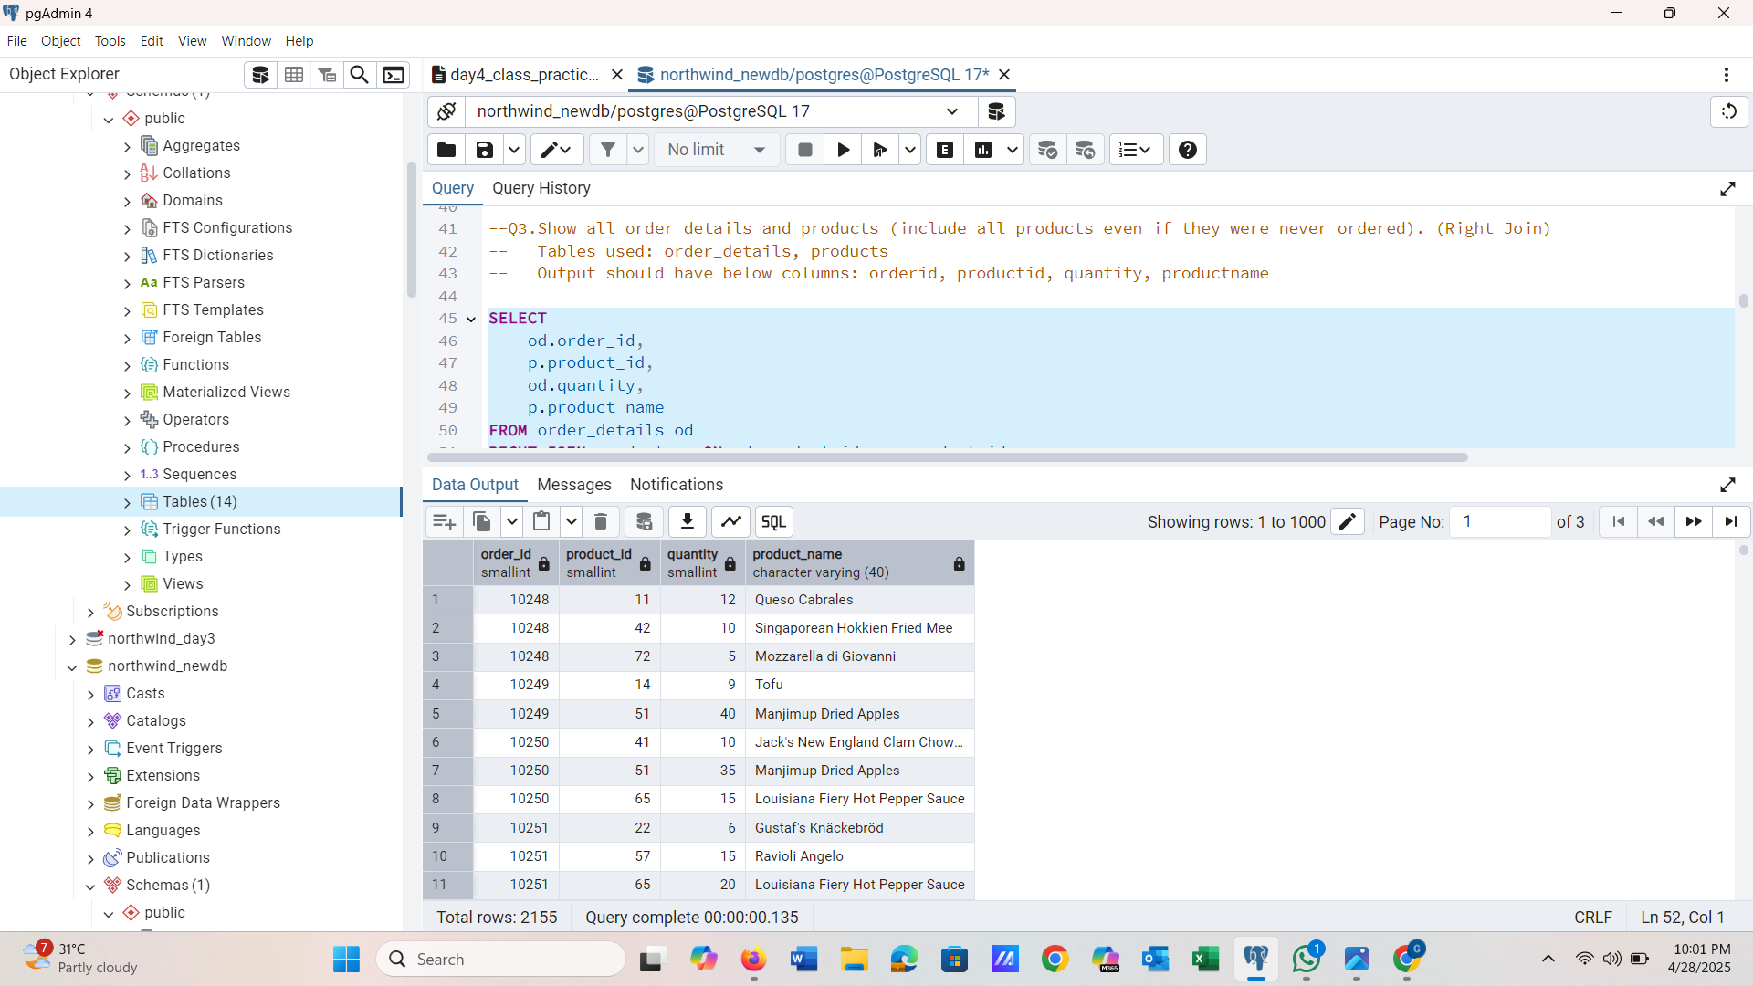

**QUESTION 4)**

**List all product categories and their products — including categories that have no products, and products that are not assigned to any category.(Outer Join)**

**QUERY DETAILS**

SELECT

c.category_name,

p.product_name

FROM categories c

FULL OUTER JOIN products p ON c.category_id = p.category_id;

**SCREENSHOTS**

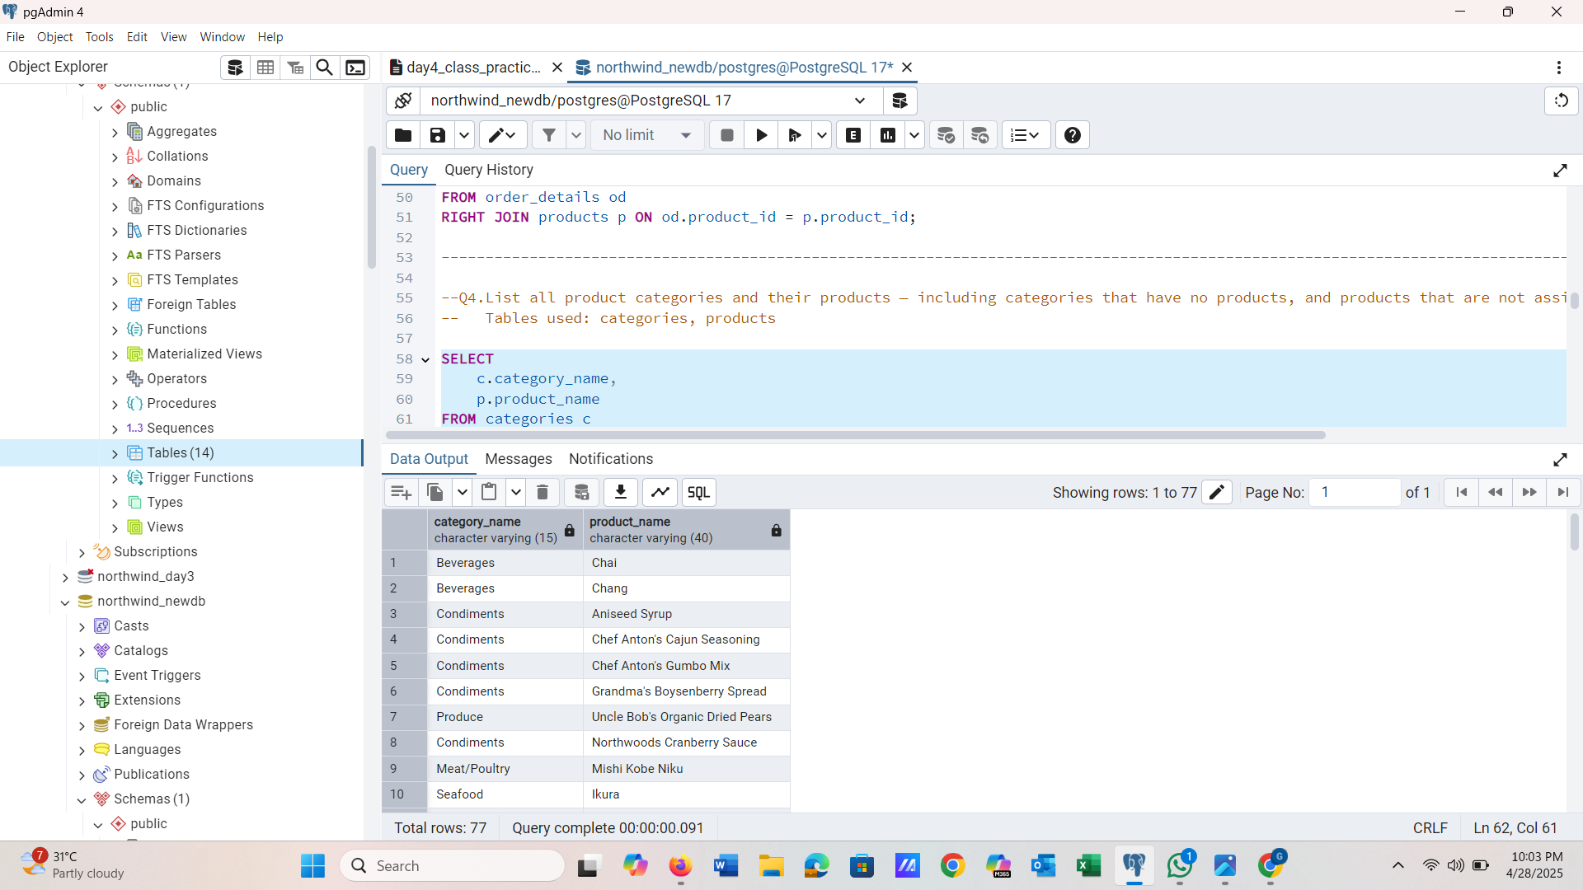

**QUESTION 5)**

**Show all possible product and category combinations (Cross join).**

**QUERY DETAILS**

SELECT

p.product_name,

c.category_name

FROM products p

CROSS JOIN categories c;

**SCREENSHOTS**

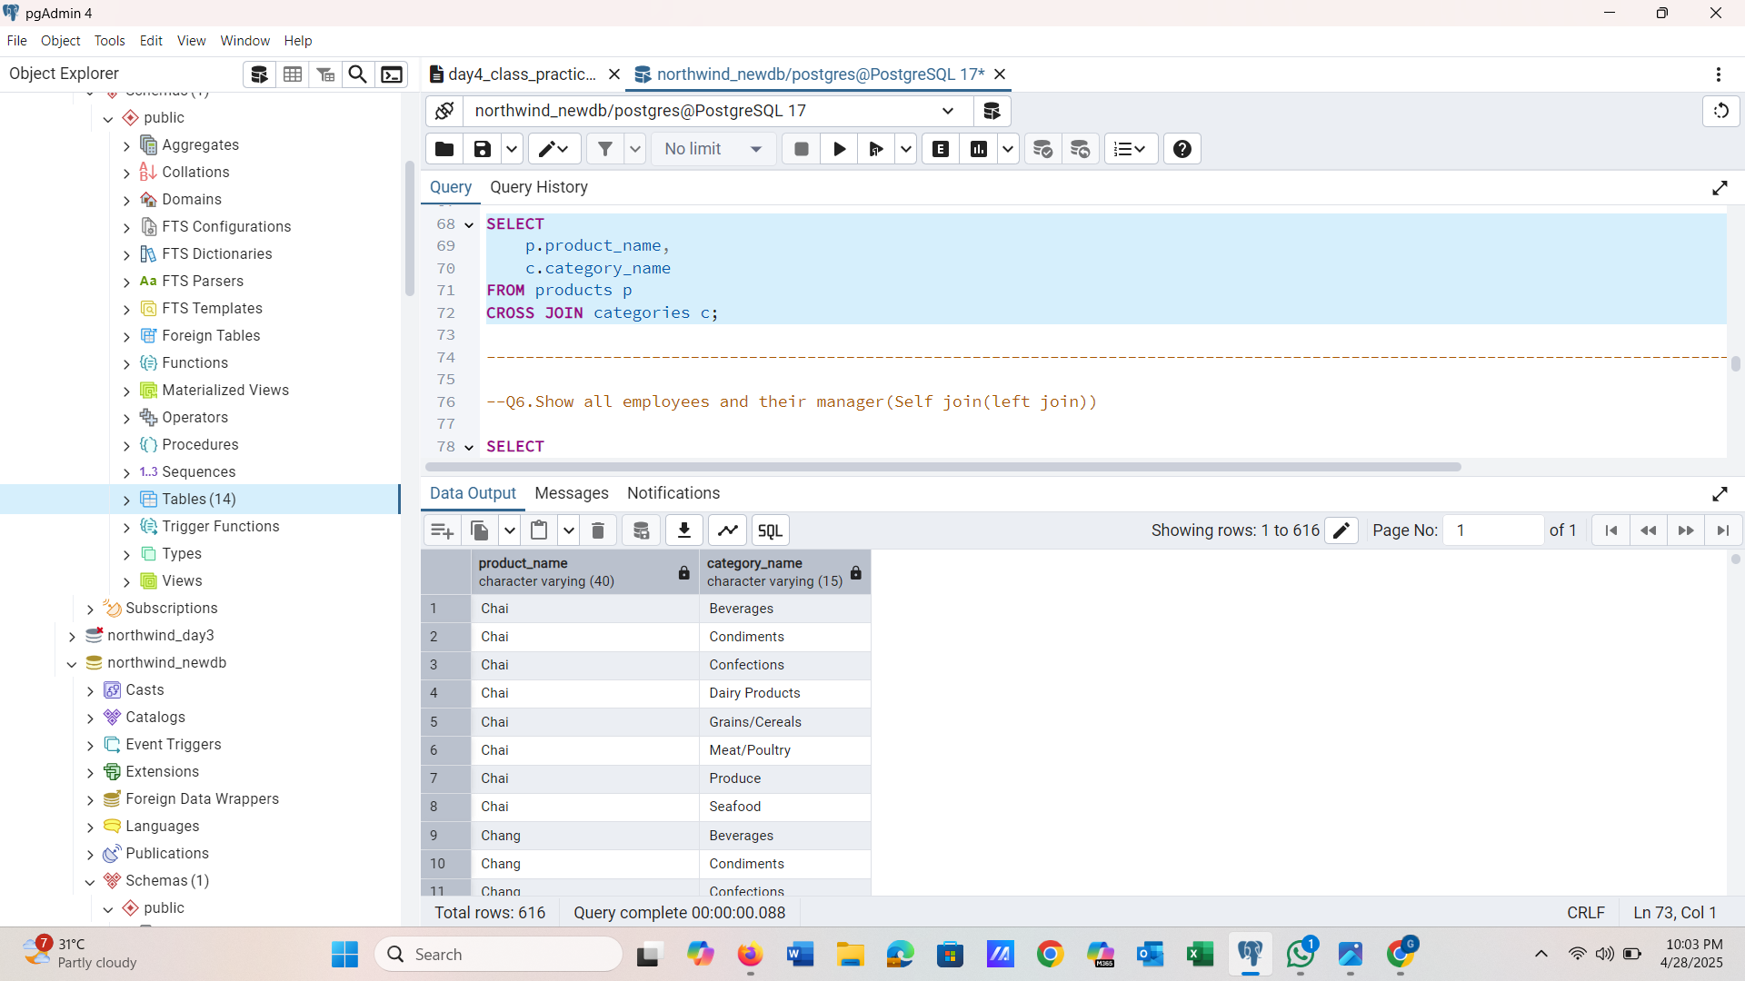

**QUESTION 6)**

**Show all employees and their manager(Self join(left join))**

**QUERY DETAILS**

SELECT

e1.first_name || ' ' || e1.last_name AS employee,

e2.first_name || ' ' || e2.last_name AS manager

FROM

employees e1

LEFT JOIN

employees e2 ON e1.reports_to = e2.employee_id;

**SCREENSHOTS**

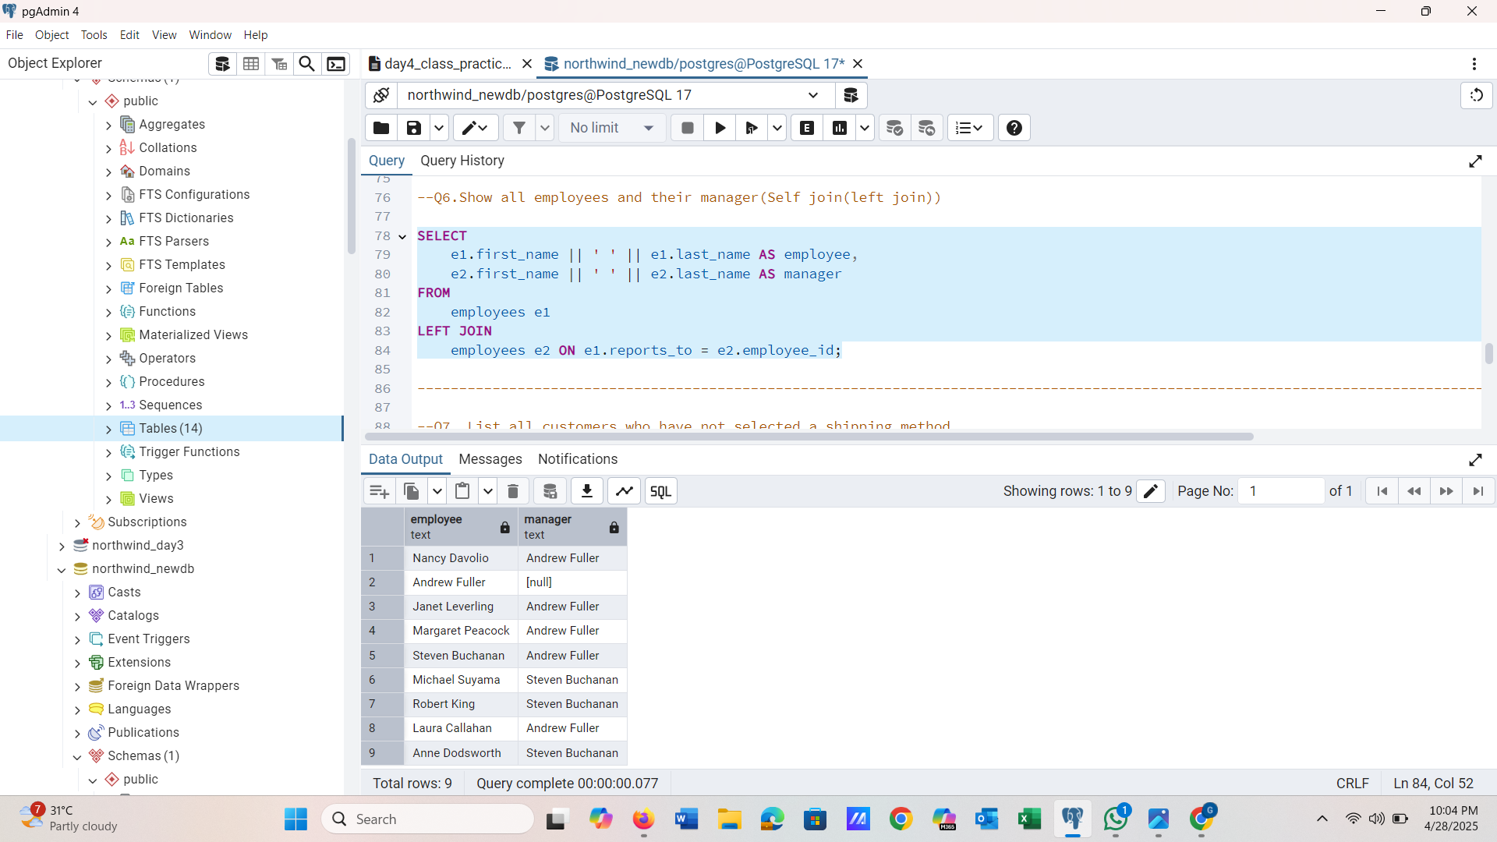

**QUESTION 7)**

**List all customers who have not selected a shipping method.**

**QUERY DETAILS**

SELECT

c.contact_name AS customers,o.ship_via

FROM

customers c

LEFT JOIN

orders o ON c.customer_id = o.customer_id

WHERE o.ship_via IS NULL;

**SCREENSHOTS**

